You are invited to a bridal shower honoring

Jane Smith

Come join us as we cook up a pot

Of love and happiness
In celebrating the upcoming marriage
of Jane Smith to John Doe.
We’ll help whisk them together
A fine froth of joy
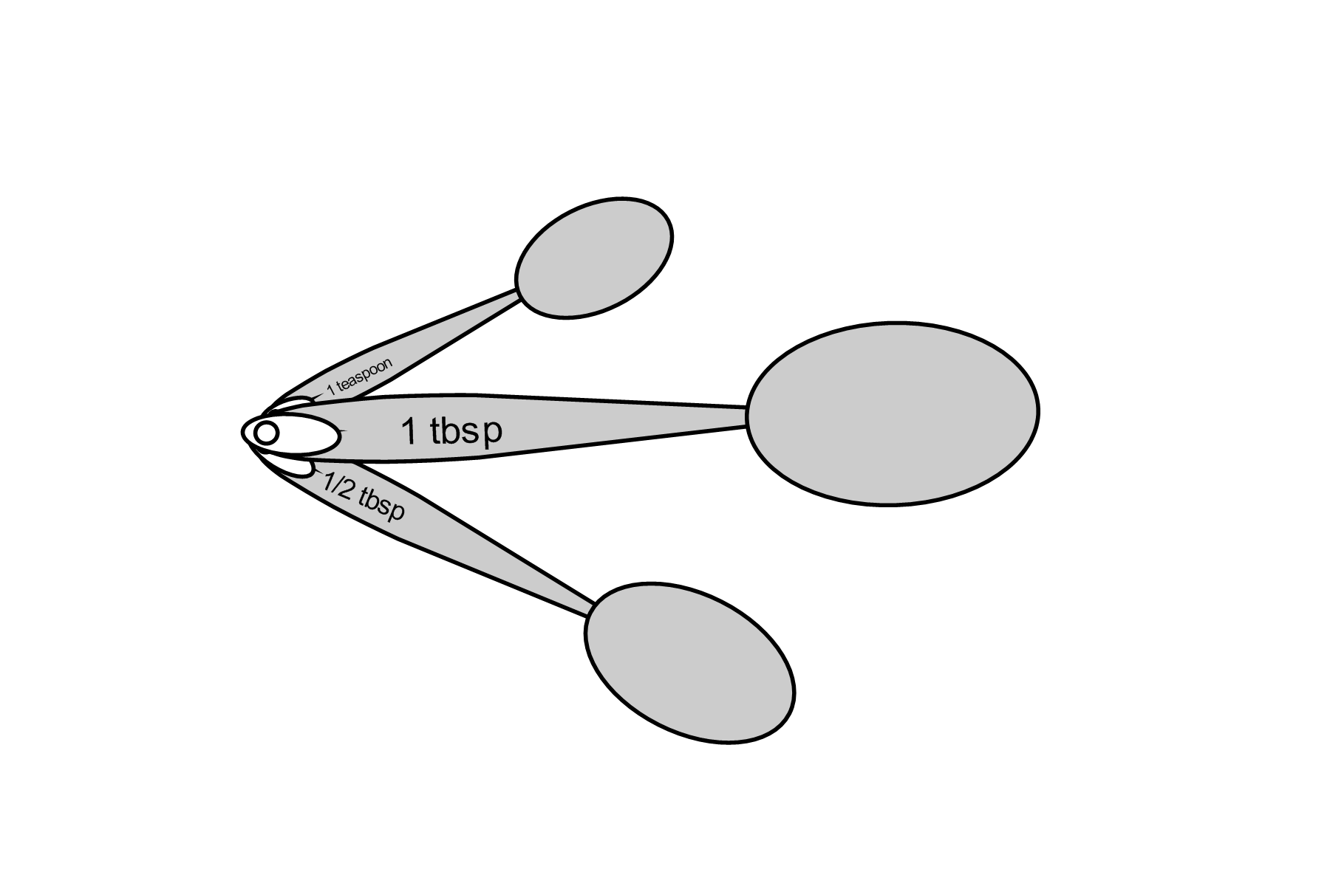
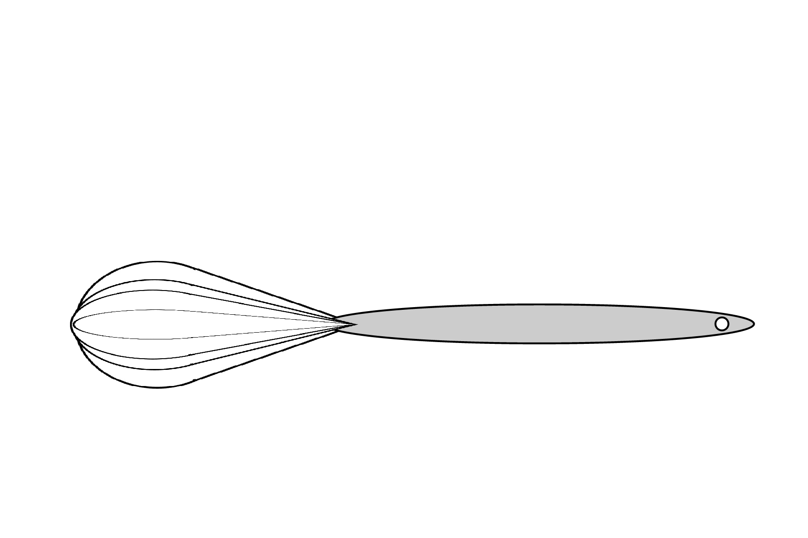
On a solid stock of friendship and trust.

At 2:00 PM
Saturday, July 31, 2008
At the home of Roberta Smith
123 Main St.
Hometown, US 10001

Jane is registered at Williams-Sonoma and Bed, Bath, and Beyond.

Please R.S.V.P. by July 25 to Jessa Smith
(123)-456-7890
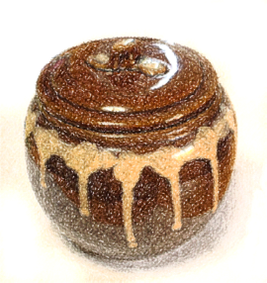

You are invited to a bridal shower honoring

Jane Smith

Come join us as we cook up a pot

Of love and happiness
In celebrating the upcoming marriage
of Jane Smith to John Doe.
We’ll help whisk them together
A fine froth of joy
On a solid stock of friendship and trust.

At 2:00 PM
Saturday, July 31, 2008
At the home of Roberta Smith
123 Main St.
Hometown, US 10001

Jane is registered at Williams-Sonoma and Bed, Bath, and Beyond.

Please R.S.V.P. by July 25 to Jessa Smith
(123)-456-7890

