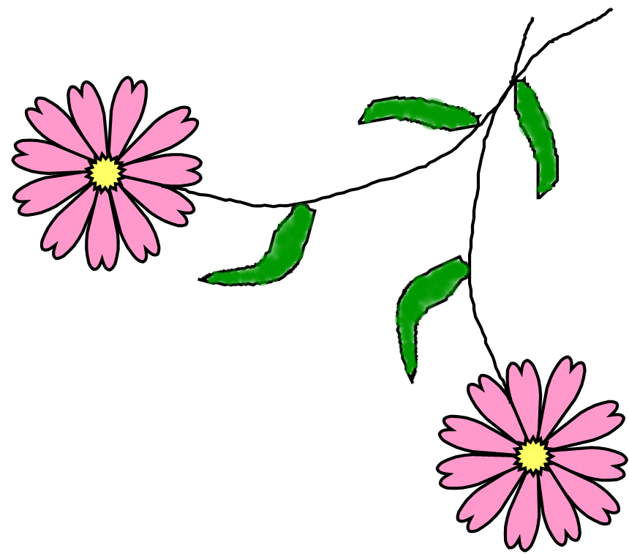
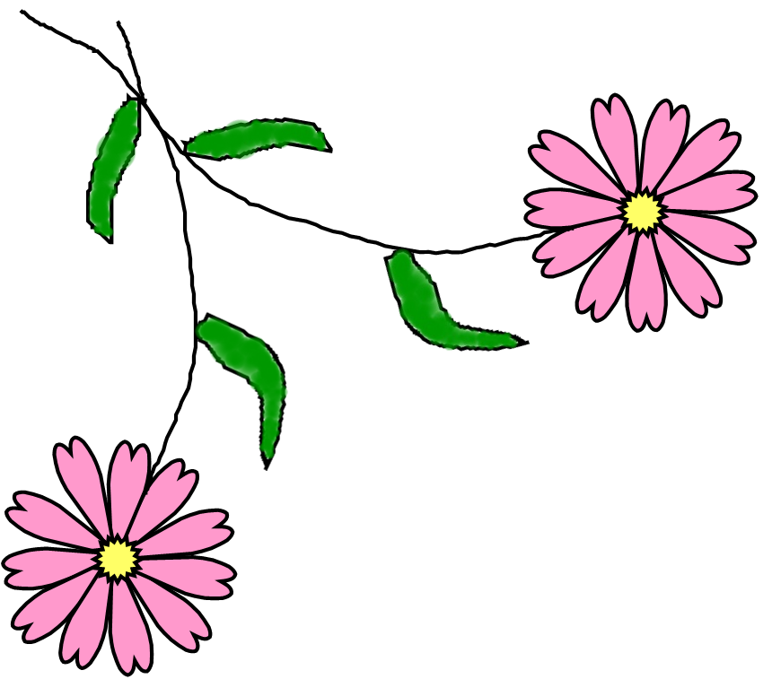

Please join us

For a tea party bridal shower honoring
Jane Smith

At 2:00 PM
Saturday, July 31, 2008
At the home of Roberta Smith
123 Main St.
Hometown, US 10001

Jane is registered at Williams-Sonoma and Amazon.com

Please R.S.V.P. by July 25 to Jessa Smith
(123)-456-7890



