Wedding Party
Jane Smith – Bride
John Doe - Groom
Melissa Miller – Matron of Honor
Jason Baker – Best Man
Madison Halle – Flower Girl
Tyson Halle – Ring Bearer
Scripture Reading – Amber Bailey
Minister – Ron Donaldson
Ushers – Jeff Halle, Joshua Kyle
Musician – Margaretta Morrison

The Wedding of John and Jane
July 31, 2008
Christ United Church
Springfield, Illinois
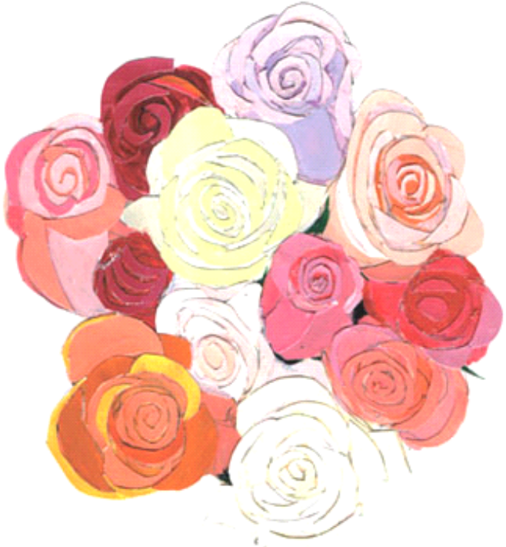

Prelude and Seating of Guests
- Gospel music
Seating of Mothers and Grandmothers
- Ave Maria
Procession of Bridal Party
- Vivaldi - Spring
Procession of Bride
- Pachelbel's Canon in D
Welcome
Prayer
Scripture Reading – Romans 12: 1-6, 9-18
Vows of Commitment
The Lord's Prayer (sung by guests - echo version)
Homily
The Giving of Rings
Lighting of the Unity Candle
Pronouncement of Marriage
Benediction
Irish Blessing – by guests
Introduction of Bride and Groom and Recessional
- Grieg – Prelude, Holberg Suite, Opus 40
Receiving line

Irish Blessing
May love and laughter light your days,
and warm your heart and home.
May good and faithful friends be yours,
wherever you may roam.
May peace and plenty bless your world
with joy that long endures.
May all life's passing seasons
bring the best to you and yours!

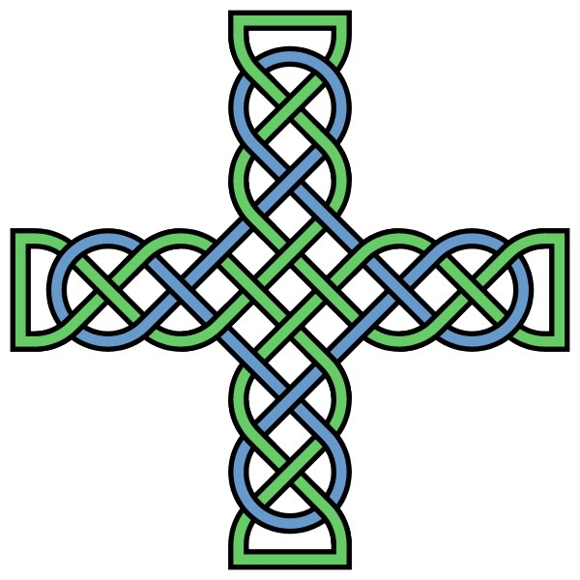

Many thanks to our parents, family, and friends for their love and support. We are grateful for you and blessed to have you here today to witness our marriage.

